Savvy Coders Week 2 Quiz – April 2019

Now that you have some general HTML knowledge, let’s check your design and CSS skills!

If you are having trouble with any of these areas, even after our review discussion, please seek an instructor or TA for help. Several concepts you will not understand until you have a lot of practice writing code and working on the command line.

1. Fill in the blanks with “inline” or “block”: Generally, ________ elements may contain only data and other ________ elements. You can't put ________ elements inside ________ elements. By default, ________ elements do not force a new line to begin in the document flow. ________ elements, on the other hand, typically cause a line break to occur (although, as usual, this can be changed using CSS).

2. For the following HTML elements, which are “inline” and which are “block”?

<p> <a>

<span> <table>

<h1> <img>

<br> <del>

<em> <div>

<input> <button>

<form> <ol>

<textarea> <label>

3. What is the function of <div>? What is its default style?

4. What is the function of <span>? What is its default style?

5. What is the following CSS model called? Identify its 5 missing labels. 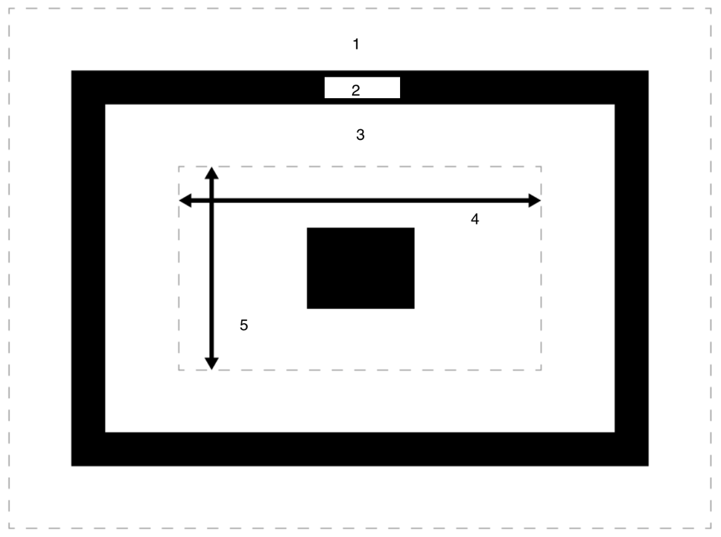

6. What does the CSS padding property do?

7. What is the difference between the following 4 padding instructions?

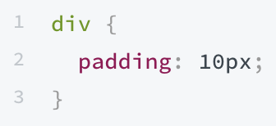

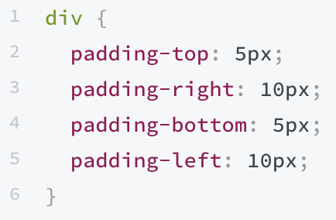

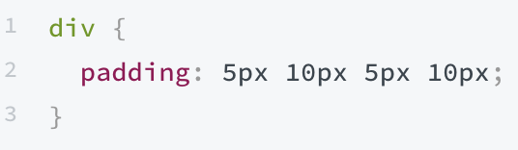

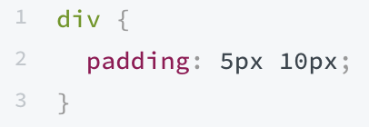

8. What does the CSS margin property do? What about CSS border property?

9. How do we set the width and height of an element?

10. What does the following CSS do? How does it work?

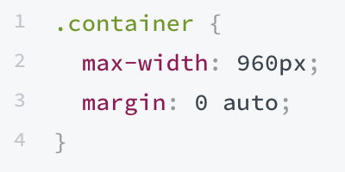

11. Explain the difference between width and max-width properties. Think: What happens to each as we shrink a window to a smaller size?

12. Let’s go over these as a class! Bonus: What symbol is used for the **universal selector**? What happens when we use the universal selector?

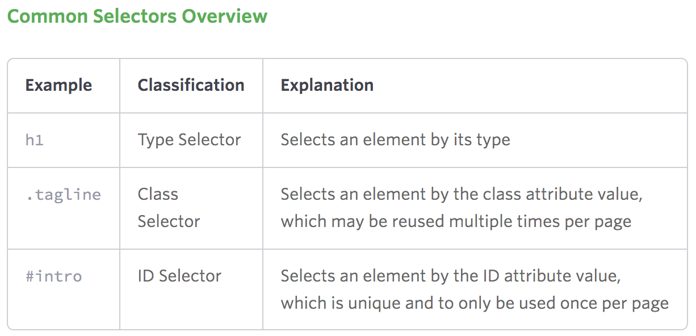

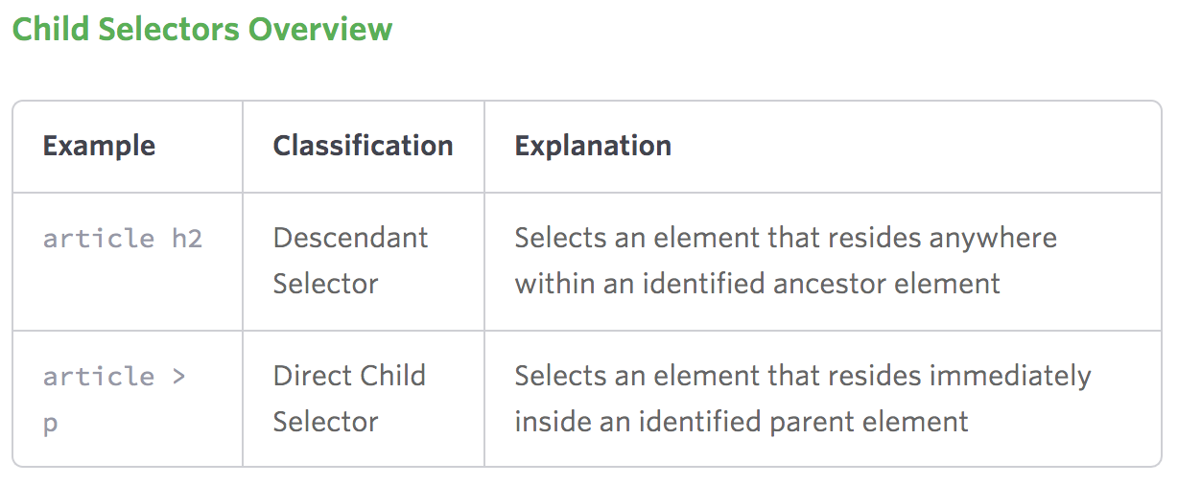

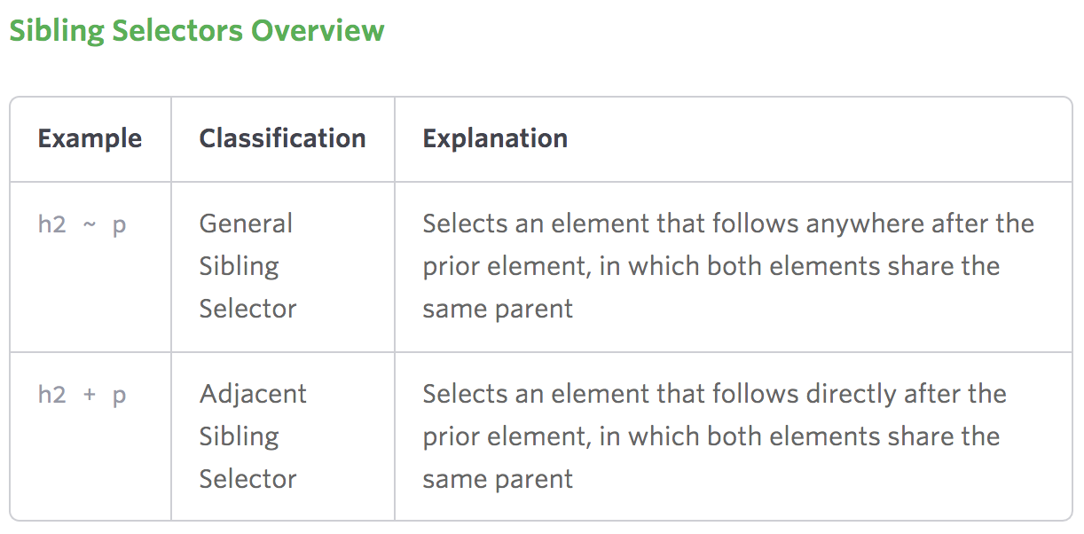

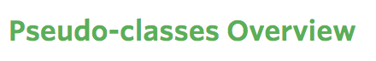

li:first-child applies to the first list item of every list

li:last-child applies to the last list item of every list

li:nth-child(2) applies to the second list item of every list

li:nth-child(2n) applies to every-other list item of every list

li:hover applies to every list item the user is hovering over

13. Fill in the blank: __________________ is the means by which browsers decide which CSS property values are the most relevant to an element and will therefore be applied.

14. True or False: The “!important” exception is bad practice because it breaks the cascading in your stylesheets and makes it difficult to debug your code.

15. Which of these three is most specific? Least? Order with 1 (highest) through 4 (lowest).

- Type selectors

- Class selectors

- ID selectors

- Style attribute

16. True or False: Inline styles added to an element (e.g., style="font-weight: bold;") always overwrite any styles in external stylesheets, and thus can be thought of as having the highest specificity.

17. True or False: Universal selector ([*](https://developer.mozilla.org/en-US/docs/Web/CSS/Universal_selectors)), combinators ([+](https://developer.mozilla.org/en-US/docs/Web/CSS/Adjacent_sibling_combinator), [>](https://developer.mozilla.org/en-US/docs/Web/CSS/Child_combinator), [~](https://developer.mozilla.org/en-US/docs/Web/CSS/General_sibling_combinator), [' '](https://developer.mozilla.org/en-US/docs/Web/CSS/Descendant_combinator), [||](https://developer.mozilla.org/en-US/docs/Web/CSS/Column_combinator)) and negation pseudo-class ([:not()](https://developer.mozilla.org/en-US/docs/Web/CSS/:not)) have no effect on specificity.

18. A ____________ contains all the CSS rules for a page.

19. Where in an HTML file do we provide the link to our CSS stylesheet? What does this link look like? What attributes does it have?

20. True or False: A stylesheet makes it easier to make changes to CSS across a document, rather than implementing <style> tags on every individual page.

21. When creating a form, what three options could you use for <input> types?

22. What HTML tag defines a form element?

23. Name the form attribute that defines where on the server the form data should be sent.

24. Name the form attribute that specifies the HTTP method.

25. True or False: HTTP works as a request-response protocol between a client and server.

26. The ___________ method is used to request data from a specified resource and its query string is sent in the URL of the request.

27. The ___________ method is used to send data to a server to create or update a resource and its data is stored in the request body of the HTTP request.

28. The CSS property of _____________ helps us align, justify, and wrap content within a container of variable width.

29. What is the difference between flexbox’s display:block and display:flex?

30. A Flexbox container has two axes: ___________ and ______________. By default, items are arranged along the ______________ axis from left to right.

31. The property of ______________ designates the position of the main axis as horizontal or vertical.

32. True or False: Flex-direction: column does not align the squares on the cross axis instead of the main axis.

33. An element with position:_________ is positioned based on the user’s scroll position.

34. A sticky element toggles between position:________ and position:________ depending on the scroll position. It is positioned __________ until a given offset position is met in the viewport, then it sticks in place.

35. True or False: For sticky positioning to work, you must specify top, right, bottom, or left (or a combination).

36. Name the four values the position property can have.

37. A ______________ is an external resource that allows you to incorporate third-party libraries and focuses on minimizing the distance between your users and the assets your site needs to render correctly.

38. A CSS ____________ is used to standardize CSS styles across all browsers because we want to have control over every aspect of our style across every browser.

39. True or False: Browsers have built-in CSS defaults and can be viewed in the user agent style sheet in dev tools.

40. The CDN we use to reset our CSS is _____________.

41. The library we use to import fonts is _____________.

42. The library we use for icons is ______________.

43. How do we get content from a CDN into our website?

44. This CSS layout design that provides a two-dimensional grid system and can be used to lay out major page areas or smaller user interface elements is ___________.

45. True or False: CSS Grid can be combined with CSS flexbox concepts.

46. The first step to creating CSS grid in your project is to build a _________________ with the property display: grid, and then all direct children of that element become grid items.

47. Rows created by the grid on its own are part of the ______________ grid. The __________ grid consists of any rows and columns defined with grid-template-columns or grid-template-rows.

48. A grid __________ is either a column or a row from its start to its end.

49. One key to having mobile-responsive websites is to have __________ queries in the CSS that give specific instructions for specific screen viewport sizes, orientations, resolutions, and devices.

50. Where are media queries placed in your CSS document? What is the notation for media queries?

51. What is responsive web design? Mobile first web design?

52. Bonus: Describe these CSS units of measurement and how they work.   
px

%

em

rem

fr

vh

vw

vmin

vmax

52. Bonus bonus: Describe the following HTTP network response code categories.

1xx 2xx

3xx 4xx

5xx